VSEPR Theory
Predicting drawing and explaining the shapes of molecules

The shapes of molecules can be predicted from their Lewis structures by using the VSEPR (Valence Shell Electron Pair Repulsion) theory. This theory states that electron groups around a central atoms will assume a geometry (shape) that keeps them as far apart from each other as possible.
An electron group can be a non-bonding pair of electrons, a bonding pair of electrons (in a single bond), a bonding quartet ( 2 pairs of e-s in a double bond), or a bonding sextet (3 pairs of e-s in a triple bond).
To predict the shape of a molecule…
- Draw a correct Lewis diagram for the molecule
- Count the electron groups (see above for the definition of electron group)
- Check against the table below

This is illustrated by the drawings and explanations below.

Number of electron groups in molecule and  Description |  | 3D image | 2 D sketch  (bonds vs non-bonding pairs)
4 | Four electron groups surrounding a central atom will form a tetrahedron. All of the angles in a tetrahedron are 109.5º, and all positions are equivalent. | 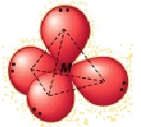 | 4 bonding groups of e-s (CH₄)  (TETRAHEDRON SHAPE)  3 bonding groups of e-s, 1 non-bonding group of e⁻s (NH₃, NF₃ )  (TRIGONAL PYRAMID SHAPE)  2 bonding groups of e-s, 2 non-bonding groups of e-s (H₂O)  (BENT SHAPE)
3 | Three electron groups surrounding a central atom will form a flat triangle (trigonal planar). Each of the angles is 120º and all positions are equivalent. | 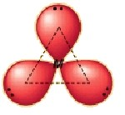 | 3 bonding groups, 0 non-bonding groups.  (TRIGONAL PLANAR)  BCl₃  Carbon cpds with 1 dbl bond and 2 single bonds around the C atom, eg:  H₂CO (4 bonding pairs but only 3 bonding groups, as 2 pairs are in the same double bond)
2 | Two electron groups surrounding a central atom form a straight line (linear) with 180º between them |  | H₂  O₂  CO₂  H₂C₂
** (high level) Non-bonding pairs of electrons are held closer to the central atom (as they are not shared or attracted to another atom), so a non-bonding pair of electrons effectively repels the other electron groups more. This is why the angles on some molecules based of a tetrahedral shape, but with non-bonding pairs (like H₂O) have angles between bonds of less than 109.5º.

So What? Why knowing about shape is important.

The arrangement of the pairs of electrons and the shape of the molecule can be used to draw inferences about the distribution of electrons within the molecule, and this can have significant impact on the strength of the intermolecular forces. Molecules which have unsymmetrical shapes often have lower than expected dispersion forces because the molecules cannot “pack” closely together. Molecules with uneven distribution of electrons within the molecule will have a molecular dipole, and thus have Dipole-Dipole intermolecular forces.
Guided practice
- Draw the Lewis structure for water, H₂O.
four
  - How many "groups" (atoms and lone pairs) surround the central oxygen?
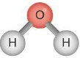
  - What is the geometry of this molecule (look at atoms and lone pairs)? Draw this VSEPR structure next to the Lewis structure.
tetrahedral
  - What is the shape of this molecule (look only at the atoms)?
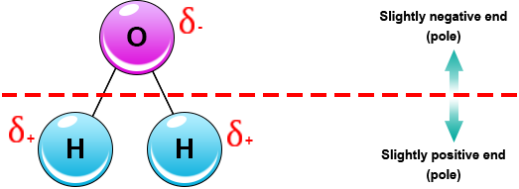
  - What is the H-O-H bond angle?
104.5º
  - Place the partial positive and negative charges on the H and O atoms, based on their relative electronegativities. Is water a polar compound?
Polar

- Draw the Lewis structure for NH₃.
  - How many "groups" (atoms and lone pairs) surround the central nitrogen?
  - What is the geometry of this molecule (look at atoms and lone pairs)? Draw this VSEPR structure next to the Lewis structure.
  - What is the shape of this molecule (look only at the atoms)?
  - What is the H-N-H bond angle?
  - Place the partial positive and negative charges on the N and O atoms, based on their relative electronegativities. Is NH₃ a polar compound?
Draw the Lewis and VSEPR structures for the following compounds and label them with their geometry.

Lewis Diagram VSEPR shape Name of shape
  - CF₄

  - H₂S

c) CO₂

d) BH₃

e) H₃CCl

f) H₂S

